**WEEK 3: - GRADED ASSIGNMENT**

**1.** Suppose we have two coins: one “fair” coin, where p(head) = p(tails) = .5; and an “unfair” coin where p(heads) does not equal p(tails). Which coin has a larger entropy prior to observing the outcome?

***A Uniform Distribution is the maximum Entropy distribution for a discrete number of outcomes. Any other distribution must have lower entropy***.

**ANSWER:- The Fair Coin**

**2.** If you roll one fair dice (6-sided), what is its entropy before the result is observed?

***For a uniform distribution across "n" things, the entropy is always equal to log(n) - here we are using log to the base 2 ; log2 (6) = 2.58 bits***

**ANSWER:- 2.58 Bits**

**3.** If your friend picks one number between 1001 to 5000, under the strategy used in video Entropy of a Guessing Game, what is the maximum number of questions you need to ask to find out that number?

***log2 (4000) = 11.965 = 12 (As explained in summary file)***

**ANSWER:- 12**

**4.** Use the “Information Gain Calculator” spreadsheet to calculate the "Conditional Entropy" H(X|Y) given a = 0.4, c = 0.5, e = 0.11.

[Information Gain Calculator.xlsx](https://d3c33hcgiwev3.cloudfront.net/_f6f6db4ff17701c688b604c51a9c1159_Information-Gain-Calculator.xlsx?Expires=1590451200&Signature=QE6whshS2qBQPAX359IareNLXNbiOo6QUG6p2dBZMg0Ol~YOUSXT~Mo~UvgYRxhXWpGzXdGZDo5~V7jZZ17eUwwYfqE4pUnwjPmugfcXSx~CtmNGMam0ahNagv~8rZjhfZgCBJ-cdRrgwtilDqperCXTZOcdIscUCt1dlHTYZbI_&Key-Pair-Id=APKAJLTNE6QMUY6HBC5A)

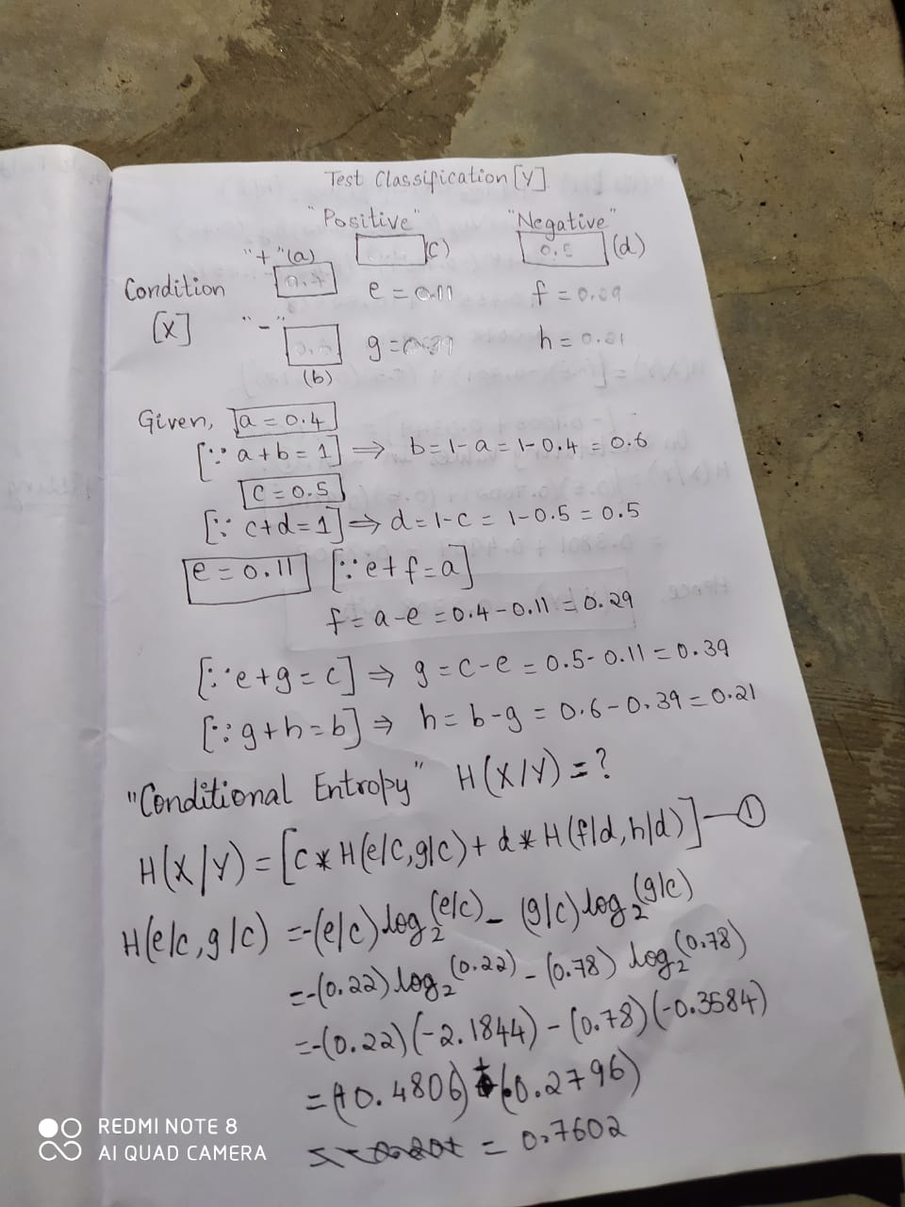 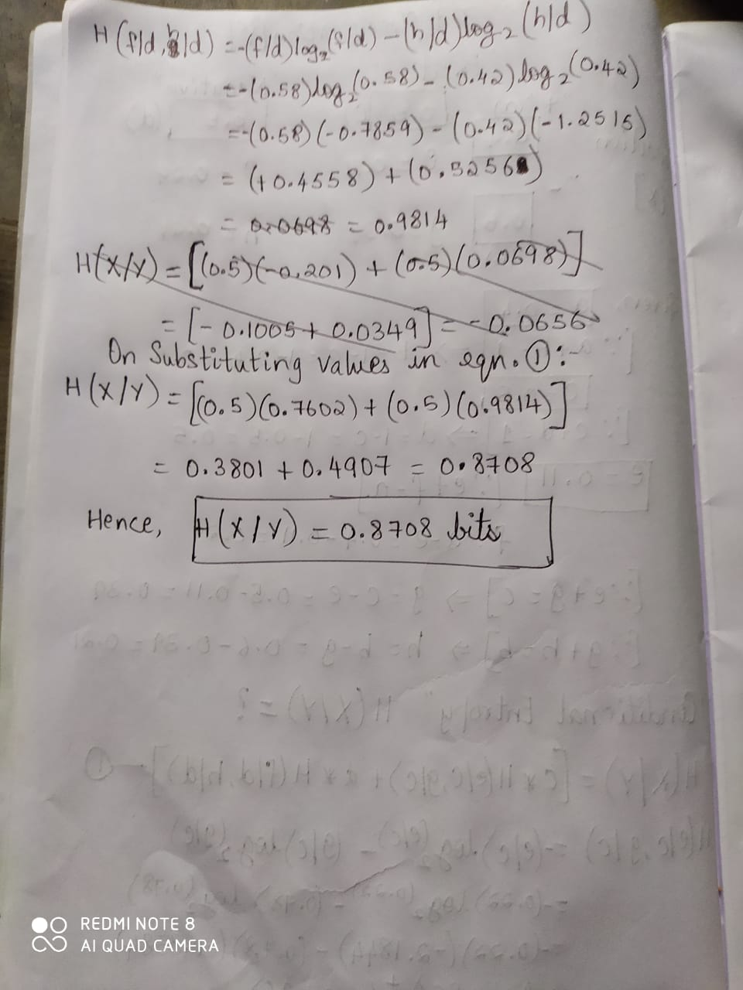

**ANSWER:- 0.87 Bits**

**5.** On the “Information Gain Calculator” spreadsheet, given a = 0.3, c = 0.2, suppose now we also know that H(X,Y) = H(X) + H(Y). What is the joint probability e?

**H(X,Y) = H(X) + H(Y) implies independence, therefore e = a*c ; e = (0.3) * (0.2) = 0.06**

**ANSWER:- 0.06**

**6**. Given *a = 0.2, c = 0.5* on the Information Gain Calculator Spreadsheet suppose now we also know the true positive rate is 0.18. What is the Mutual Information?

[Information Gain Calculator.xlsx](https://d3c33hcgiwev3.cloudfront.net/_f6f6db4ff17701c688b604c51a9c1159_Information-Gain-Calculator.xlsx?Expires=1590451200&Signature=QE6whshS2qBQPAX359IareNLXNbiOo6QUG6p2dBZMg0Ol~YOUSXT~Mo~UvgYRxhXWpGzXdGZDo5~V7jZZ17eUwwYfqE4pUnwjPmugfcXSx~CtmNGMam0ahNagv~8rZjhfZgCBJ-cdRrgwtilDqperCXTZOcdIscUCt1dlHTYZbI_&Key-Pair-Id=APKAJLTNE6QMUY6HBC5A)

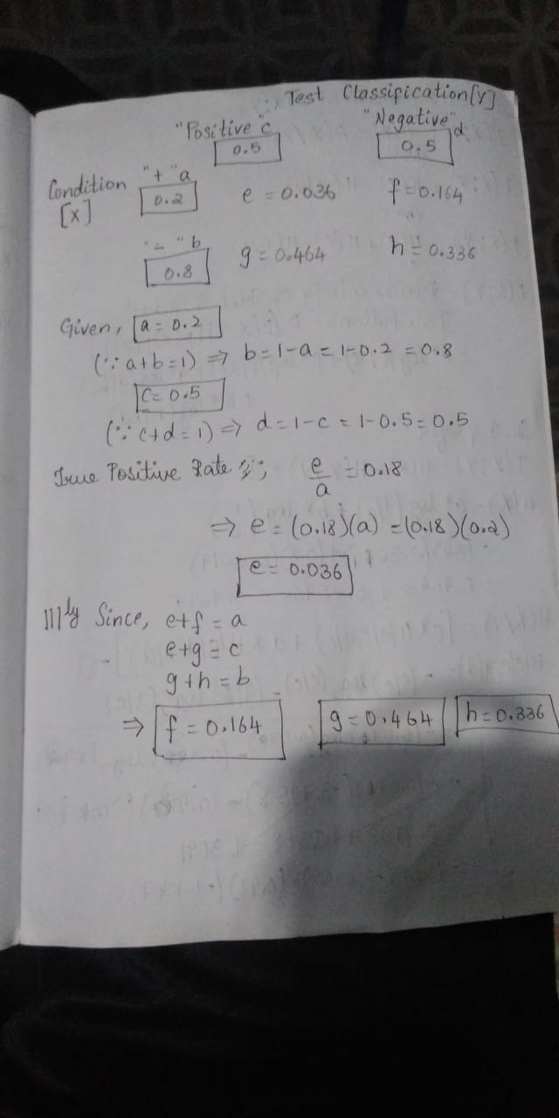 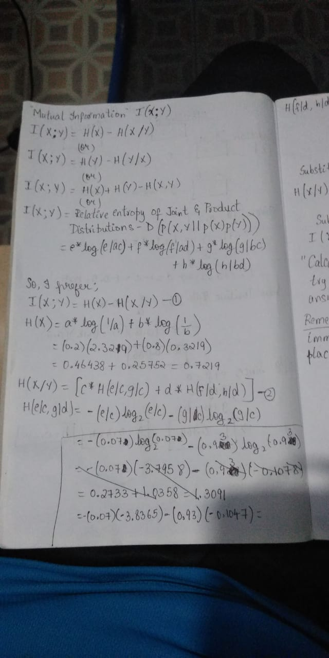

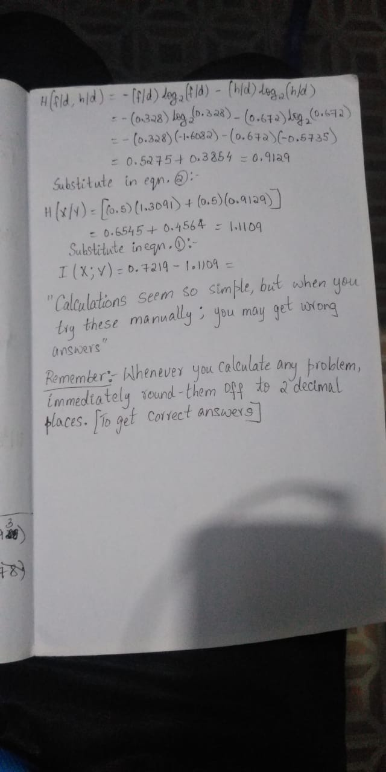

***Remember * - Whenever you solve a problem round off the values to 2 decimal values***

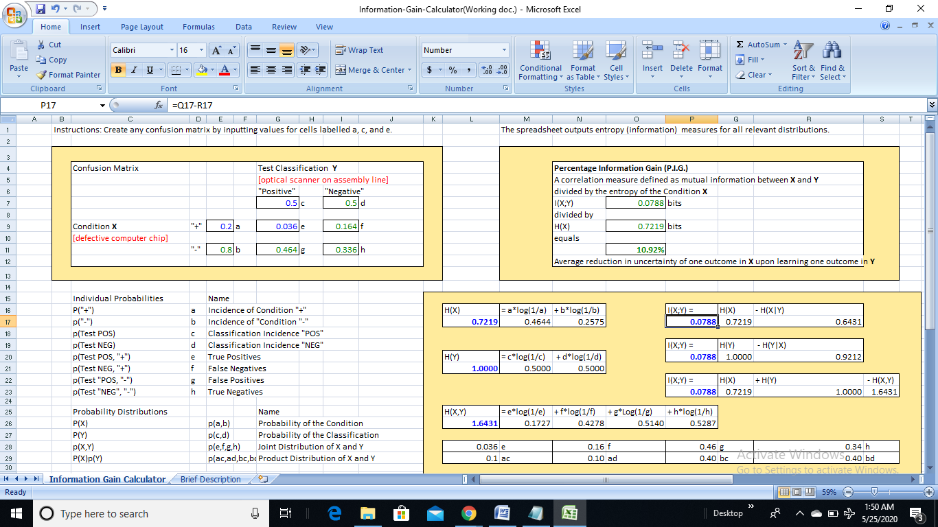

***Mutual Information = 0.0788 = 0.08 bits***

**ANSWER:- 0.08 Bits**

**7.** Consider the Monty Hall problem, but instead of the usual 3 doors, assume there are 5 doors to choose from. You first choose door #1. Monty opens doors #2 and #3. What is the new probability that there is a prize behind door #4?

***Probability of prize in Door 1, 2, 3, 4, 5(Before Monty opens Door 2 or 3) :- 1/5***

***Probability of prize in Door 1(After Monty opens Door 2) :- 1/5***

***Probability of prize in Door 3,4, 5 (After Monty opens Door 2) :- 2/5***

***Probability of prize in Door 1 (After Monty opens Door 2 & 3) :- 1/5***

***Probability of prize in Door 4,5 (After Monty opens Door 2 & 3) :- 2/5 = 0.4***

**ANSWER:- 0.4**

**8.** Again, consider the Monty Hall problem, but with 5 doors to choose from instead of 3. You pick door #1, and Monty opens 2 of the other 4 doors. How many bits of information are communicated to you by Monty when you observe which two doors he opens?

***Initial entropy: 1/5*log(2,5/1) * 5 = 2.32***

***After opened 2 doors: 1/5*log(2,5/1) + 2/5*log(2,5/2) * 2 = 1.52***

***Information gain = 2.32 - 1.52 = 0.8***

**ANSWER:- 0.8**

**9.** B stands for “the coin is fair”, ~B stands for “the coin is crooked”. The p(heads | B) = 0.5, and p(heads | ~B) = 0.4. Your friend tells you that he often tests people to see if they can guess whether he is using the fair coin or the crooked coin, but that he is careful to use the crooked coin 70% of the time. He tosses the coin once and it comes up heads.

What is your new best estimate of the probability that the coin he just tossed is fair?

***Given:***

***P(heads | B) = 0.5***

***P(heads | ~B) = 0.4***

***P(~B) = 0.7***

***Want to know:***

***P(B | heads)***

***Calculations:***

***P(B) = 1 - P(~B) = 1- 0.7 = 0.3***

***P(heads) = P(B) * P(heads | B) + P(~B) * P(heads | ~B) = (0.3)*(0.5) +(0.7)*(0.4) =0.15+0.28 = 0.43***

***P(B | heads) = P(heads | B) * P(B) / P(heads) = (0.5)*(0.3) / (0.43) = 0.15/0.43 = 0.3488 = 0.35***

**ANSWER:- 0.35**

**10.** Suppose you are given either a fair dice or an unfair dice (6-sided). You have no basis for considering either dice more likely before you roll it and observe an outcome. For the fair dice, the chance of observing “3” is 1/6. For the unfair dice, the chance of observing “3” is 1/3. After rolling the unknown dice, you observe the outcome to be 3.

What is the new probability that the die you rolled is fair?

***Given: A- The Coin is Fair ; ˜A – The Coin is Unfair***

***P(3| A) = 1/6 = 0.17***

***P(3| ~A) = 1/3 = 0.33***

***P(~A) = 0.5; P(A)= 0.5***

***Want to know:***

***P(A | 3)***

***Calculations:***

***P(3) = P(A) * P(3 |A) + P(~A) * P(3 | ~A) = (0.5)*(0.17) +(0.5)*(0.33) =0.08+0.16 = 0.24***

***P(A |3) = P(3 |A) * P(A) / P(3) = (0.17)*(0.5) / (0.24) = 0.08/0.24= 0.33***

**ANSWER:- 0.33**

***You can solve Sums from Information Gain Calculator, but I have posted the solutions by solving them…to have a practice…(Its better u solve sums and cross-check them in Excel sheet provided)***